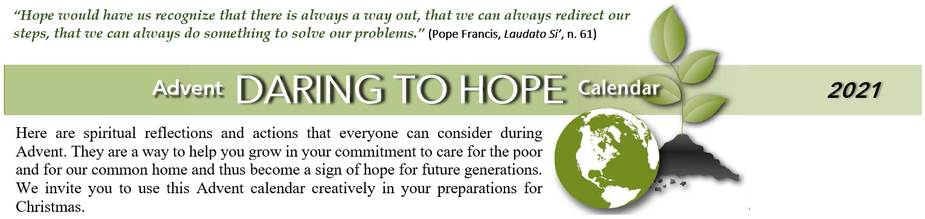
SUNDAY | MONDAY | TUESDAY | WEDNESDAY | THURSDAY | FRIDAY | SATURDAY
“Through Noah, who remained innocent and just, God decided to open a path of salvation. In this way, he gave humanity the chance of a new beginning. All it takes is one good person to restore hope.”  Pope Francis, the encyclical Laudato Si’, n.71 |  |  | December, 1  Reflect with gratitude on your connection with God, the human family and earth’s community of life. | 2  Prayerfully reflect on the charity and justice projects included in this year’s Christmas Alternative Gift Fair. Find your cause, support it, invite others to join you in it. | 3  Look to purchase locally grown food. Go to a farmer’s market or consider joining a community-supported agriculture (CSA) group for fresh produce: LocalHarvest.org | 4  All recent Popes have spoken on our eco-responsibilities. Reflect and pray on St. John Paul II’s “Peace with God the Creator, Peace with All of Creation.” bit.ly/JP2-on-ecology
December 5  In today’ Gospel we hear: “Prepare the Way of the Lord, make straight his paths.” Reflect on what you and your family might already be doing to live sustainably. | 6  Save energy this week: find 5 incandescent light bulbs in your house and replace them with efficient LED bulbs. They pay back in energy savings in 6 months! | 7  "You are not making a gift of what is yours to the poor man, but you are giving him back what is his... The earth belongs to everyone, not to the rich." St Ambrose. Help climate refugees. | 8  In today’s Gospel we hear that “nothing will be impossible for God.” Believe that you can make a difference. Calculate your “water footprint” save water: watercalculator.org/ wfc2 | 9  Shift to cleaner energy at home by buying 100% renewable power on your electricity bill. Find out more at: www.green-e.org/certified-resources# | John 8:12 10  Those who follow you, Lord, will have the light of life.  Reflect on how eating more plant-based meals may be a way to help the poor & to follow Jesus. | 11  Combine trips today or walk, bike, or use public transportation. Check store sites on the web or call ahead to make sure the trip is worth it.
12  “From panoramic vistas to the tiniest living form, nature is a constant source of wonder and awe. It is also a continuing revelation of the divine.” Pope Francis | 13  Save energy this week: run the clothes washer on “cold/cold” setting and only when you have full loads. | 14  Minimize disposables at home. Use a cloth napkin for several meals. Wipe up with a dish cloth instead of paper towels. | 15  In today’s first reading we heard Prophet Isaiah pray: “Let justice descend, O heavens, like dew from above.” Learn about Catholic Social Teachings and the New Green Deal * | 16  Minimize disposables at work. Use a mug for coffee and water. Carry lunch in reusable food containers. | 17  Check out Oxfam’s “Eat for Good” website to explore how to shop for food and eat sustainably: bit.ly/eat4good | 18  Take a walk in nature and observe the interdependence of all God’s Creation. Spend time thanking God for what you see, smell, and feel around you. and for what God has made.
SUNDAY | MONDAY | TUESDAY | WEDNESDAY | THURSDAY | FRIDAY | SATURDAY
December 19  Reflect and pray on Pope Benedict XVI’s message for the World Day of Peace, “If You Want to Cultivate Peace, Protect Creation.” bit.ly/pope-benedict-protect-creation | 20  Save energy this week: place an insulating cover on your electric water heater. If you have an oil- or gas-fired water heater, consult with a plumber before installing it. | 21  Today’s Gospel reminds us that Mary believed that “what was spoken to her by the Lord would be fulfilled.” Ask Mary to help you believe in God’s promise of life for the Earth community. | 22  Learn to compost. Find out what a huge difference it makes and why. Watch a short video * | 23  Decide to go organic in your garden this spring. Grow your lawn & garden without toxic chemicals. Leave grass clippings on the lawn and cut the grass higher. | 24  Pray with Zechariah for justice for the poor and healing of the earth: “In the tender compassion of our God the dawn from on high shall break upon us, to shine on those who dwell in darkness and the shadow of death, and to guide our feet into the way of peace.” | 25  We hear in the Gospel today that, “All things came to be through Him” (that is, Christ, the eternal Word of God). Reflect on those words and your daring hope in God’s power to heal and transform the earth.  Join a social movement to climate justice.

“When the Roman Empire was seeking to impose absolute dominion, the faithful would once again find consolation and hope in a growing trust in the all-powerful God: “Great and wonderful are your deeds, O Lord God the Almighty! Just and true are your ways!” (Rev. 15:3) The God who created the universe out of nothing can also intervene in this world and overcome every form of evil. Injustice is not invincible.” Pope Francis in Laudato Si’, n. 74
“Politics and business have been slow to react in a way commensurate with the urgency of the challenges facing our world. Although the post-industrial period may well be remembered as one of the most irresponsible in history, nonetheless there is reason to hope that humanity at the dawn of the twenty-first century will be remembered for having generously shouldered its grave responsibilities.” Pope Francis in Laudato Si’, n. 165

*Catholics Social Teachings and the Green New Deal/ a webinar from the Catholic Climate Covenant https://www.bing.com/videos/search?q=Catholic+Climate+Covenant&docid=608019321760142548&mid=D80A5925F3962E91D2EED80A5925F3962E91D2EE&view=detail&FORM=VIRE

*A video, The Compost Story https://www.youtube.com/watch?v=bqDQD8cvO5Y&t=8s

The above links are also available on the website of the Immaculate Conception Church under Advent program.

