Earth Day Prayer: In the Spirit of Indigenous Traditions

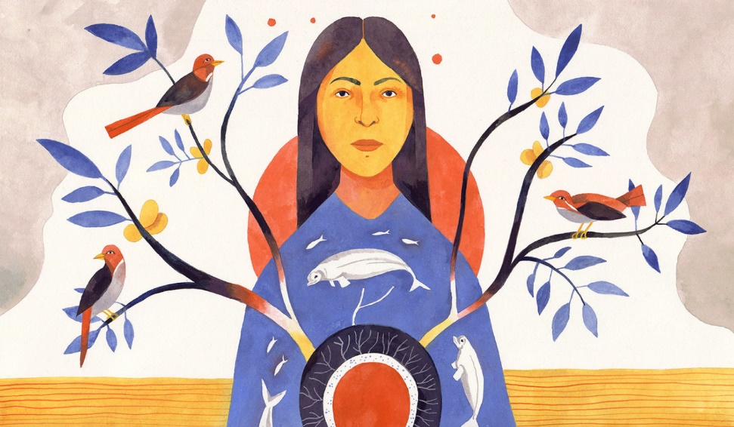

Infinite Spirit,
We gather to praise your creation,
to honor the swimmers and crawlers,
the four-leggeds and the winged ones;
we give thanks for the beauty and glory of creation
and open our hearts to new ways to understand
our place in the universe—not the center or focus,
but a humble and balanced place,
where every step we take becomes a prayer,
where every word we say
makes harmony with the vast, vibrating cosmos,
and where we know we are singing the song of life.
We pray to know more deeply that we are in the Garden
where every plant and animal and speck of dust
is a living prayer.
Without our brothers and sisters
of the plant and animal and mineral kingdoms,
the human family would end.
So we want to bless them, as they bless us.
We pray for humility—
to humble ourselves before the ants and trees—
for if we cannot be in true relation to the ants and the trees,
we shall be outcasts of the garden.
Let us cast the pollution from our eyes
so we can see the glory and live with thanksgiving.
Great Spirit, let us remember
it is not how we talk but how we walk.
When we say we love animals, let us protect them.
When we say that we love the plants,
let us honor them by living lightly on Earth.
When we say we love the minerals,
let us use them only in necessity,
and remember their rightful places.
Oil belongs in the ground,
not in the air through our wasteful machines.
Wondrous trees, breathing life into the atmosphere:
your gifts of fire and shelter, fruit,
and sailing are precious to us.
And in many ways you offer us leaves of knowledge.
May the vision of mutual interrelatedness,
cosmic interdependence,
the seamless process of generations,
not end in cough-filled skies blotting the sun,
but rather may clear air, healthy forests,
wholesome water, expansive prairie, and pungent earth
nourish paths for all creatures
through mountain and valley, and the salt sea,
and through a protective atmosphere,
as we rejoice in the inhabitants.
With thanks for the surprise and mystery of it all,
we pray in the name of the Creator,
and all our relations.
So be it.
By Vern Barnet

